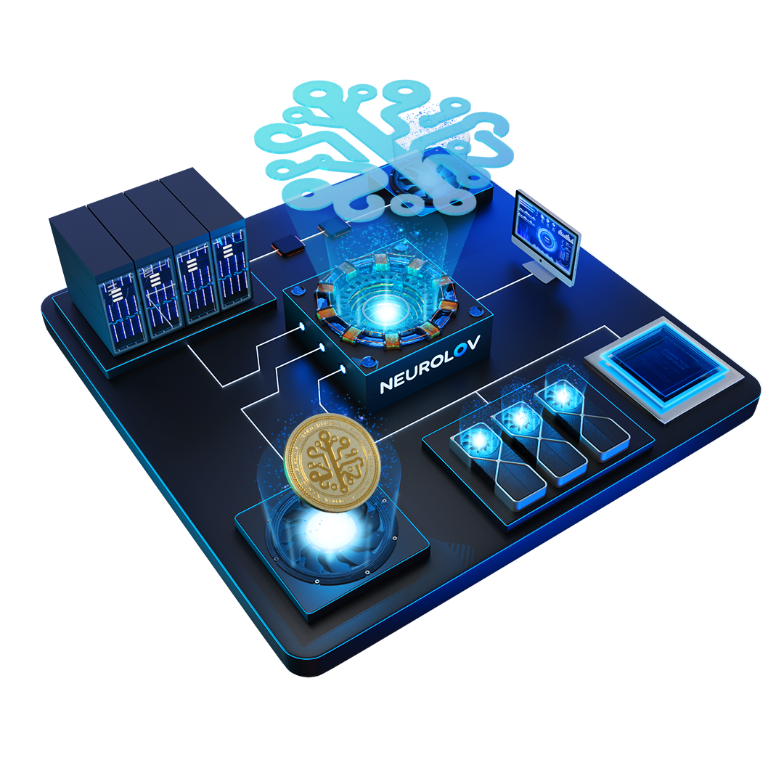

White Paper

V3

**Neurolov**

1. Introduction

In the rapidly evolving landscape of artificial intelligence the demand for high-performance computer resources, notably Graphics Processing Units is constantly increasing. Despite the ubiquitous availability of GPUs, a large amount of their processing capability is wasted due to idle time and geographical dispersion. This under-utilization creates a dilemma since it represents a missed opportunity to use these tremendous resources for beneficial purposes. Traditional centralized computer systems are unable to successfully handle this issue because of constraints in scalability, accessibility, and cost-effectiveness. Furthermore, centralized systems frequently experience bottlenecks and single points of failure, limiting their capacity to fully utilize.

In response to these problems, we propose a novel method that revolutionizes how compute is utilized. At the forefront, Neurolov aims to democratize access to high performance computing resources by combining decentralized technology with Artificial Intelligence. Designed to optimize resource allocation and workload management in a simplified manner to enhance efficiency and feasibility for the end users.

2. Mission and Vision

Our mission is to completely transform the way cutting-edge AI technologies are used and integrated. Our goal is to give developers and businesses the state-of-the-art resources and tools they need to build scalable, secure, and intelligent artificial intelligence solutions. Our goal is to increase the efficiency, affordability, and accessibility of AI development by utilizing the latest large language models (LLMs) and GPU plug-in compute technologies. This will foster innovation and improve capabilities.

Our vision is to push the limits of artificial intelligence (AI) and spearhead the shift towards artificial general intelligence (AGI). In our ideal future, artificial intelligence (AI) agents would be effortlessly incorporated into routine activities, boosting human potential and raising standards of living. we hope to arrive at a point where AI systems not only facilitate but also stimulate advancement and creativity in humankind.

1. Market Analysis

The global market for GPUs and high-performance computing resources is predicted to reach a valuation of over $26 billion by 2032[1], exhibiting exponential development. GPUs are the fuel of the future, driving rapid advancements in AI and ML by providing unparalleled processing power, efficiency, and scalability for next-generation technological innovations. Growing demands from a variety of businesses, including artificial intelligence, gaming, and data research, are driving this expansion. The market is hampered by restricted availability, which is made worse by production limitations and  
geographical differences, notwithstanding this remarkable development trajectory.

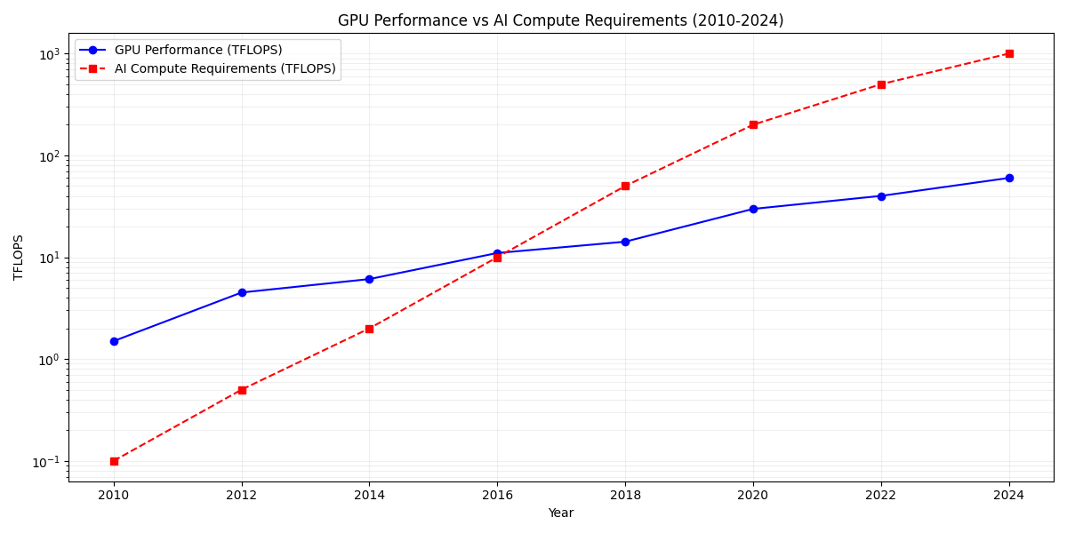

Figure 1: GPU Performance VS AI Compute Requirements (2010-2024)

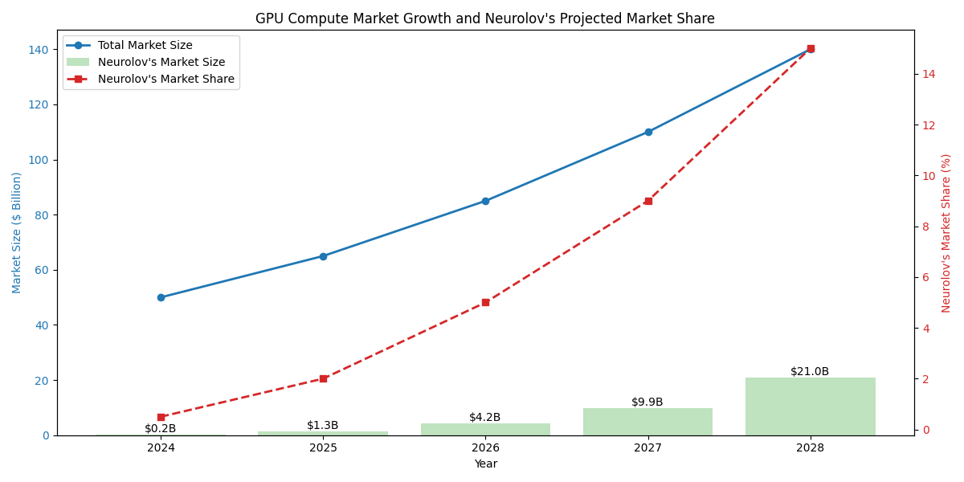  
Figure 2: GPU Compute Market Growth vs Projected Market Share

We are poised to capitalize these market dynamics with an innovative approach by leveraging unused GPU resources and establishing a decentralized computing network. By addressing key market challenges and providing users with access to high-performance computing in a cost-effective and sustainable manner, Neurolov is strategically positioned to capitalize on these market dynamics by offering a decentralized, efficient, and accessible solution to high-performance computing needs.

4. Problem Statement  
  
Many obstacles prevent the GPU and high-performance computing markets from being as accessible and optimized as they may be. The most significant of these issues is the widespread under-use of GPU resources, This under-utilization is caused by things like downtime, production limitations, and unequal resource allocation across different geographic areas. Due to their inability to manage resources effectively, centralized computing solutions make these problems worse by limiting scalability, creating security holes, and creating operational inefficiencies. Users frequently encounter challenges while trying to acquire and use GPU resources, which leads to less-than-ideal performance and higher expenses. Furthermore, the centralized structure of current systems poses dangers like single points of failure and raises questions regarding the security and privacy of data. There is an urgent need for decentralized systems that can provide improved resilience, accessibility, and efficiency given the growing demand for computers. In response to these difficulties, Neurolov was born, with the goal of transforming GPU computing through the utilization of unused GPU resources.

5. Solution Overview

By building a decentralized computing network that utilizes idle GPU capabilities worldwide, Neurolov tackles the issues facing the high-performance computing industries. Users can simply get around the restrictions of conventional centralized systems and access high-performance processing power.

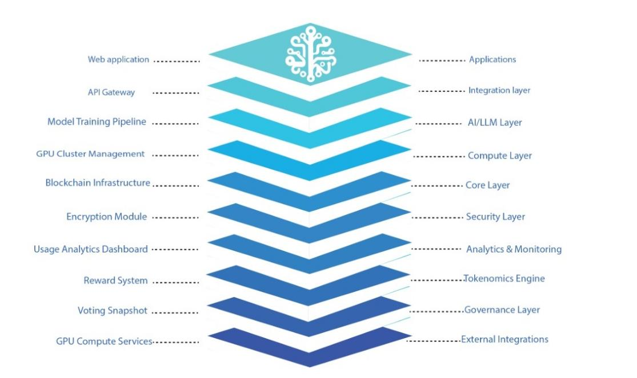  
Figure 3: Technical Architecture

It guarantees equitable and effective resource distribution through the use of smart contracts and consensus procedures, allowing for the on-demand leasing of GPU compute capability. By optimizing GPU utilization, this method lowers user expenses while improving processing efficiency[2]. The platform's key features include easy access to GPU processing power, decentralized governance that upholds platform integrity and stakeholder participation, scalable infrastructure that adjusts to changing computational demands, and improved security via the use of cryptography and distributed storage systems. All things considered, the platform provides a complete answer to the problems facing the GPU computing sector, giving consumers access to high-performance processing power in a decentralized way.

6. Technical Architecture

Neurolov's cutting-edge technical architecture leverages synergistic convergence of blockchain, AI, and distributed computing paradigms to revolutionize the GPU-as-a-Service landscape. Our groundbreaking platform harnesses the power of Web3 technologies, implementing a decentralized neural network of idle GPU resources to democratize access to high-performance computing. By utilizing advanced machine learning algorithms, quantum-resistant cryptography, and AI-driven resource allocation, Neurolov delivers an unparalleled, scalable solution for next-generation LLM development and rendering tasks. Our proprietary consensus mechanism, coupled with state-of-the-art homomorphic encryption, ensures seamless interoperability and ironclad security across the ecosystem. This disruptive technology stack, combined with our tokenomics-driven incentive model, positions Neurolov at the vanguard of the decentralized AI revolution, poised to capture significant market share.

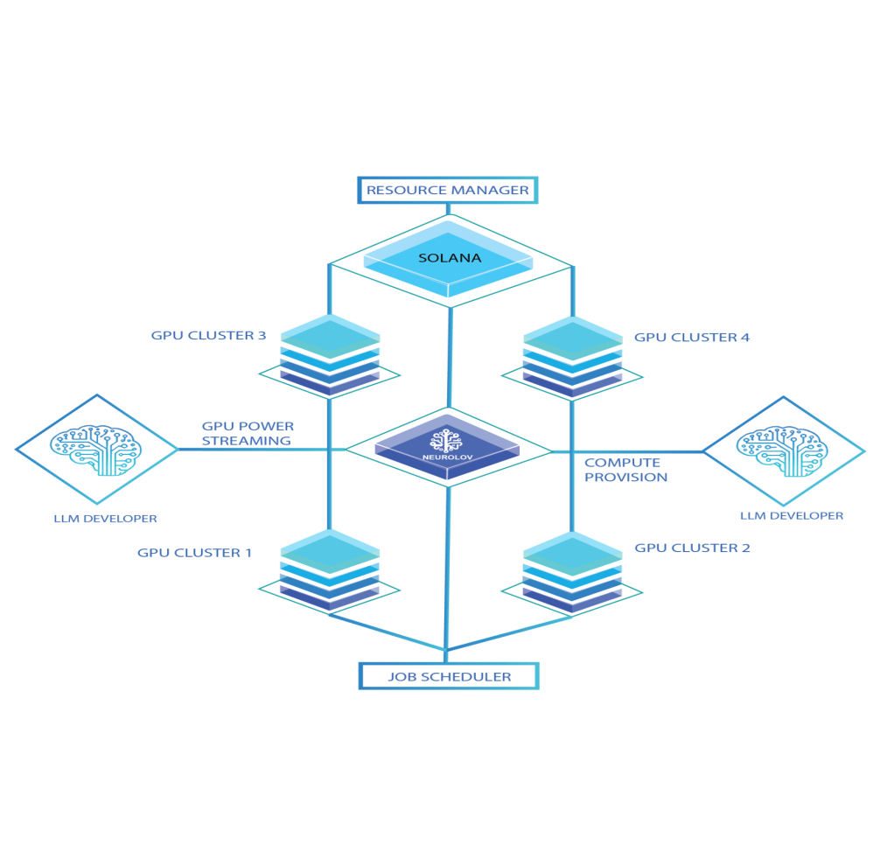  
Figure 4: Solution Architecture

6.1 Smart Contract Structure

The Neurolov ecosystem employs a sophisticated smart contract architecture comprising several interconnected modules that work in concert to create a robust, decentralized GPU marketplace. At its core, the *UserManager* module handles user registration and authentication, ensuring secure access to the platform. The *GPUMarketplace* contract serves as the central hub, managing GPU listings, facilitating rentals, and processing payments between providers and renters. Complementing this, the *TokenManager* oversees Neurolov token transactions and staking mechanisms, incentivizing participation and aligning user interests with the platform's success. The *GovernanceModule* empowers the community by enabling voting on proposals and executing decisions, fostering a truly decentralized ecosystem. These contracts interact seamlessly, leveraging blockchain technology to ensure transparency, security, and efficiency. Additional features include automated dispute resolution, dynamic pricing algorithms based on supply and demand, and integration with decentralized identity solutions for enhanced user verification. The architecture also incorporates scalability measures, such as layer-2 solutions and sharding, to accommodate growing transaction volumes. Furthermore, the system includes comprehensive auditing and monitoring capabilities to maintain the integrity of the marketplace and protect against potential vulnerabilities.

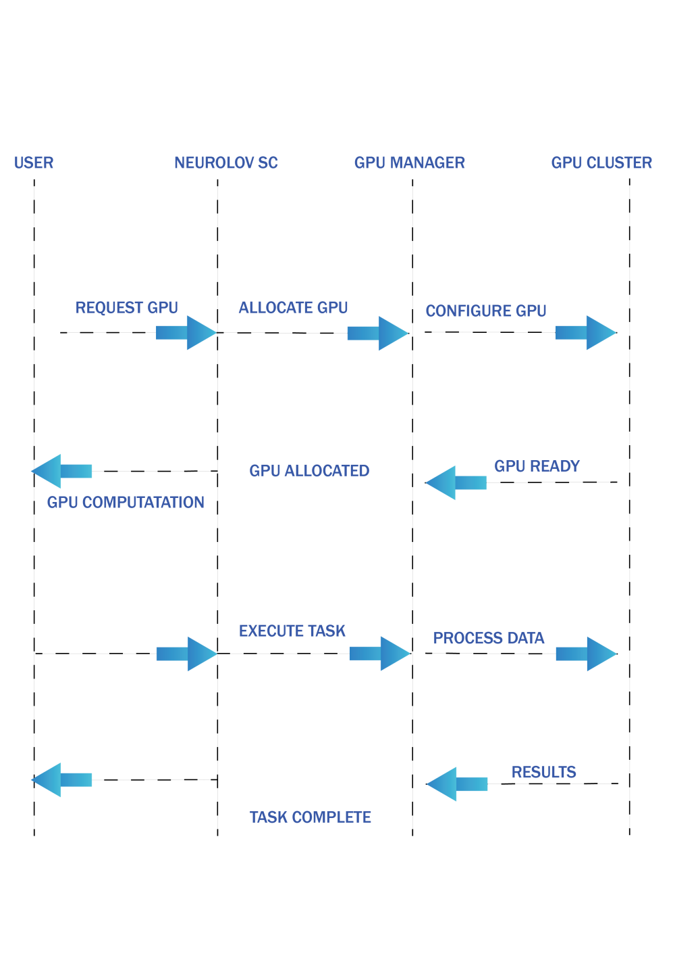

Figure 5: Smart Contract Sequence

6.2 Off-Chain Components

The Neurolov platform's off-chain infrastructure complements its on-chain components, creating a comprehensive ecosystem for decentralized AI and GPU computing. At the heart of this infrastructure is the *GPU Cluster Manager*, a sophisticated system that orchestrates GPU resources across multiple data centers, ensuring optimal allocation and utilization of computing power. This manager interfaces with the on-chain *GPUMarketplace* contract to match supply with demand efficiently.

The *AI Model Repository* serves as a crucial component, storing and versioning AI models and datasets. This repository enables seamless access to cutting-edge AI tools and vast datasets, facilitating rapid development and deployment of AI applications. It likely employs advanced version control systems and access management protocols to maintain data integrity and user privacy.

To maintain the quality and reliability of computations, the *Result Validator* plays a critical role. This component ensures the integrity of computed results, by employing consensus mechanisms and or cryptographic proofs to verify outputs. This validation process is essential for building trust in the decentralized computing network.

The *Analytics Engine* provides valuable insights into platform usage and performance. By aggregating and analyzing data from various sources, it offers stakeholders a comprehensive view of the ecosystem's health, user behavior, and market trends. This information is crucial for continuous improvement and strategic decision-making.

These off-chain components communicate with on-chain contracts through secure *oracles* and *APIs*, bridging the gap between the blockchain and external systems. This integration likely involves sophisticated encryption and authentication mechanisms to maintain the security and integrity of data flows. The use of oracles ensures that real-world data can be reliably incorporated into smartcontract operations, enhancing the platform's functionality and responsiveness to external conditions.

Additionally, the infrastructure include *load balancers*, content *delivery networks*, and *distributed storage solutions* to ensure high availability and performance. Security measures such as firewalls, intrusion detection systems, and regular security audits are likely implemented to protect against potential threats. The entire off-chain ecosystem is designed to scale horizontally, allowing for the seamless addition of resources as the platform grows.

6.3 UI and UX

The Neurolov platform boasts an intuitive and comprehensive user interface that caters to a diverse user base, from AI experts to novice users, ensuring accessibility and efficiency across various skill levels. At the core of this interface is a D*ynamic Dashboard*, which serves as the central hub for users to gain a quick overview of critical information.This Dashboard likely features real-time data visualizations, displaying available GPU resources, ongoing computational tasks, and up-to-date account balances.

The Marketplace component forms the heart of the platform's economic ecosystem, providing a user-friendly interface for browsing and renting GPU resources. This includes advanced filtering and sorting options, detailed GPU specifications, pricing information, and user reviews to facilitate informed decision-making. The integration of Web3 technology enables seamless interactions allowing secure transactions.

For AI practitioners, the Model Management section offers a powerful suite of tools for uploading, training, and deploying AI models. This component includes features such as version control, collaborative editing, and integration with popular AI frameworks. It may also offer per-configured templates and workflows to streamline the development process.

The Community Hub fosters user engagement and platform governance, serving as a central location for discussions, knowledge sharing, and participation in the decision-making process. This is done through *Snapshot* which include forums and a voting interface for governance proposals, enhancing the platform's decentralized nature.

Additional features include a comprehensive help center with tutorials and documentation, a notification system for important updates or task completions, and personalized recommendations based on user behavior and preferences. The interface employs responsive design principles to ensure compatibility across various devices and screen sizes, potentially even offering mobile applications for on-the-go management.

6.4 WebGPU

A relatively new web standard, provides low-level access to GPU capabilities within web browsers. Its inclusion in the Neurolov ecosystem enables several key advantages:  
  
**Client-side GPU Computations**: By leveraging WebGPU, the platform can offload certain computations directly to the user's local GPU. This capability is particularly beneficial for tasks that don't require the full power of data center GPUs or for preliminary data processing. It could significantly reduce the load on the platform.

**Reduced Latency for AI Tasks:** The ability to perform some AI operations locally can dramatically reduce latency for certain tasks. This is especially valuable for real-time applications such as image or video processing, natural language processing, or interactive machine learning models. Users can experience more responsive AI interactions without the delay of constant server communication.

**Enhanced User Experience with Real-time Visualizations**: WebGPU enables GPU-accelerated visualizations directly in the browser. This could be used to create dynamic dashboards, interactive model exploration tools, or real-time data visualizations. For AI researchers and data scientists, this means being able to interact with their models and data in more intuitive and immediate ways. This feature could be particularly powerful when combined with the platform's distributed computing capabilities. For example, a complex AI task could be split between local GPU processing for immediate feedback and cloud GPU processing .   
  
However, it's important to note that WebGPU support varies across browsers and devices. Hence the platform includes fallback mechanisms for users without WebGPU support, ensuring a consistent experience across different setups. This not only enhances the user experience but also opens up new possibilities for hybrid local-cloud GPU computing models, further expanding the platform's capabilities and efficiency.

7. GPU Allocation and Management

The Neurolov platform employs a sophisticated resource allocation algorithm to optimize GPU distribution, ensuring efficient utilization of computational resources while balancing user priorities and task requirements. This algorithm takes into account multiple factors to make informed allocation decisions, creating a fair and efficient marketplace for GPU resources.

The algorithm's core components consider three primary factors:

**User Priority**: This is determined by the user's Neurolov token stake, reflecting their investment and commitment to the platform. Users with higher stakes are given priority, incentivizing long-term engagement and platform growth.

**Task Urgency**: This factor considers the time-sensitive nature of the computational task, allowing critical or time-bound projects to receive prioritized access to resources.

**Task Complexity**: This element assesses the computational demands of the task, ensuring that more complex jobs receive appropriate resources.

The algorithm employs a multi-factor scoring system to quantify these considerations:

*Score = (User Stake * 0.4) + (Task Urgency * 0.3) + (Task Complexity * 0.3)*

This weighted formula allows for a nuanced approach to resource allocation. The user's stake carries the highest weight (40%), reflecting the importance of user investment in the platform. Task urgency and complexity are equally weighted (30% each), balancing the need for timely execution with the demands of computationally intensive tasks.

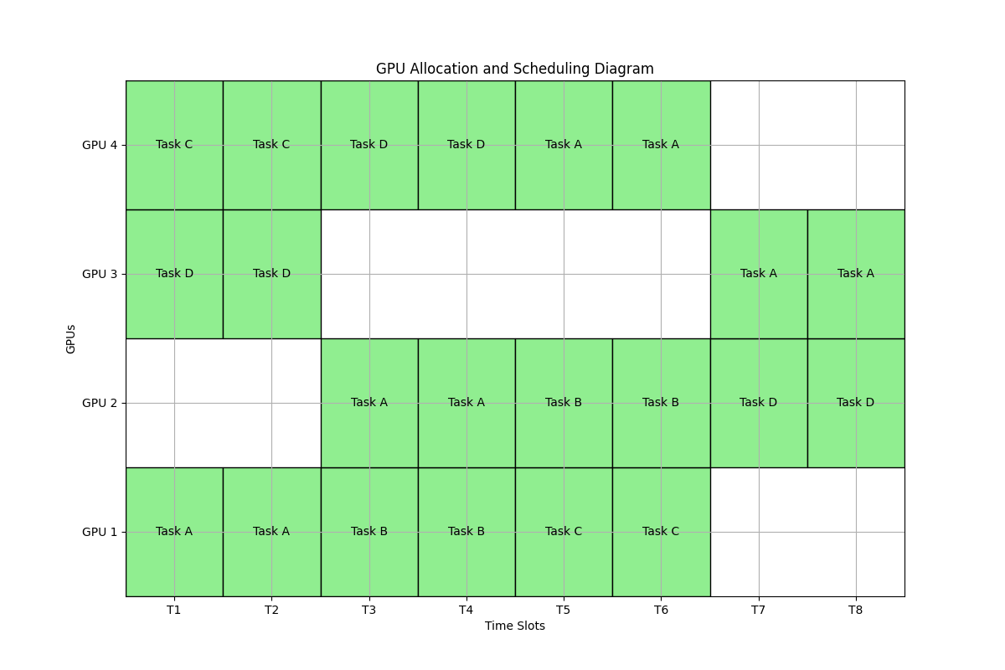

Figure 6: GPU Allocation and Scheduling

GPUs are then allocated to the highest-scoring tasks first, ensuring that the most critical and valuable computations receive priority. This approach optimizes resource utilization while maintaining a fair system that rewards platform engagement. The algorithm incorporates additional factors such as current GPU availability and load to fine-tune allocations in real-time. This could involve load balancing across multiple data centers, considering network latency, and potentially even factoring in energy efficiency or cost considerations.

To enhance its effectiveness, the algorithm also employ machine learning techniques to adapt and improve over time, learning from historical data to better predict resource needs and optimize allocations. It might also include fail-safe mechanisms to prevent *resource monopolization* and ensure a minimum level of access for all users.

This resource allocation system not only ensures efficient GPU utilization but also creates a dynamic marketplace where users are incentive to stake Neurolov tokens and prioritize their most important tasks. The transparency and fairness of this algorithm contribute to building trust in the platform, encouraging broader participation in the decentralized GPU computing ecosystem.

The platform employs a sophisticated approach to GPU resource management, incorporating dynamic pricing, advanced multi-GPU training capabilities, and optimization strategies to ensure efficient utilization and fair pricing. Let's break down these components:  
  
**Dynamic Pricing Model**: The platform uses a responsive pricing model that adapts to market conditions and resource characteristics. The formula:

*Price=BasePrice * (1 + DemandFactor) * (1 + CapabilityFactor) * SeasonalAdjustment*

This model considers supply and demand fluctuations, time-based usage patterns, and specific GPU capabilities. The *DemandFactor* likely increases during peak usage times, while the *CapabilityFactor* adjusts pricing based on the GPU's specifications. The *SeasonalAdjustment* factor probably accounts for longer-term trends in usage. This dynamic approach ensures that pricing remains fair and responsive to market conditions, incentivizing efficient resource allocation.

**Multi-GPU Training Capabilities:** Neurolov supports distributed training across multiple GPUs, offering three main parallelization strategies:

1. **Data Parallelism**: Ideal for large datasets, this approach distributes data across multiple GPUs, enabling faster processing of voluminous information.
2. **Model Parallelism**: This strategy is crucial for large, complex models that exceed the memory capacity of a single GPU, allowing different parts of the model to be processed on separate GPUs.
3. **Pipeline Parallelism**: By splitting model layers across GPUs, this approach optimizes the flow of data through the network, potentially reducing latency and improving throughput.

The system's ability to automatically determine the best parallelization strategy based on model architecture and available resources is a significant feature. This automation likely   
involves analyzing the model's structure, memory requirements, and the characteristics of available GPUs to choose the most efficient distribution method.

**GPU Utilization Optimization**: To maximize resource efficiency, Neurolov implements several key strategies:

1. **Task Queuing**: This system manages waiting tasks to minimize GPU idle time, likely employing sophisticated scheduling algorithms to optimize task allocation and execution.
2. **Dynamic Voltage and Frequency Scaling (DVFS**): By adjusting GPU power consumption based on workload, this feature optimizes energy efficiency without compromising performance, potentially reducing operational costs.
3. **Smart Batching**: Combining smaller tasks to fully utilize GPU capacity is an intelligent approach to maximizing throughput and efficiency, especially for users with less demanding workloads.

These optimizations work together to ensure high resource efficiency and cost-effectiveness for users. The system likely employs machine learning algorithms to continuously refine these strategies based on usage patterns and performance data.   
  
Overall, this comprehensive approach to resource management, pricing, and optimization creates a robust and efficient marketplace for GPU computing resources. It balances the needs of different user types, from those requiring massive computational power for complex models to users with smaller, more routine tasks. The platform's ability to dynamically adjust to changing conditions and automatically optimize resource allocation positions it as a sophisticated solution in the decentralized AI and GPU computing space.

8. AI Capabilities   
An important obstacle in the development of AGI is the massive amount of processing power needed to train AI models. Neurolov has developed a novel program for renting GPUs to overcome this issue. Through an easy-to-use interface, Neurolov makes high-performance computing capability more accessible to a wider range of users. Even small-scale researchers and developers will have access to the computational resources required for training complex AI and ML models thanks to this GPU power sharing arrangement.

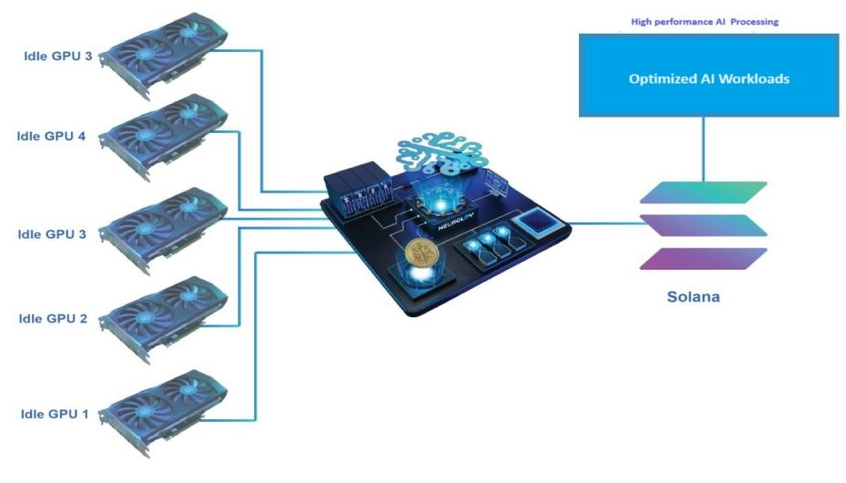

Figure 7: AI Modeling

8.1 Comprehensive AI Model Support

Neurolov offers extensive support for a wide range of AI models, including *CNNs* for image processing, *RNNs* and *LSTMs* for sequence data, Transformer models for *NLP* tasks, *GANs* for content creation, and Reinforcement Learning models for decision making tasks. Pre-trained versions of popular models such as *BERT, GPT,* and *ResNet* are available for quick deployment and fine-tuning.

8.2 Advanced LLM Fine-tuning

The platform provides advanced LLM fine-tuning capabilities, supporting prompt engineering, few-shot learning, and efficient fine-tuning techniques like *LoRA.* Users can optimize hyper parameters for enhanced model performance and leverage distributed training for large language models, enabling easy adaptation of state-of-the-art LLMs to specific use cases.

8.3 Intelligent Model Selection

Neurolov features an intelligent model selection algorithm that analyzes input data characteristics, task requirements, and available GPU resources to recommend the most suitable model architecture and size. This ensures efficient resource utilization and optimal task performance across various AI applications.

8.4 Federated Learning Implementation  
  
To facilitate collaborative model training while preserving data privacy, Neurolov implements federated learning. This includes secure aggregation of model updates from multiple participants, differential privacy techniques to prevent data leakage, adaptive federated optimization algorithms for faster convergence, and support for both cross-silo and cross-device federated learning scenarios.

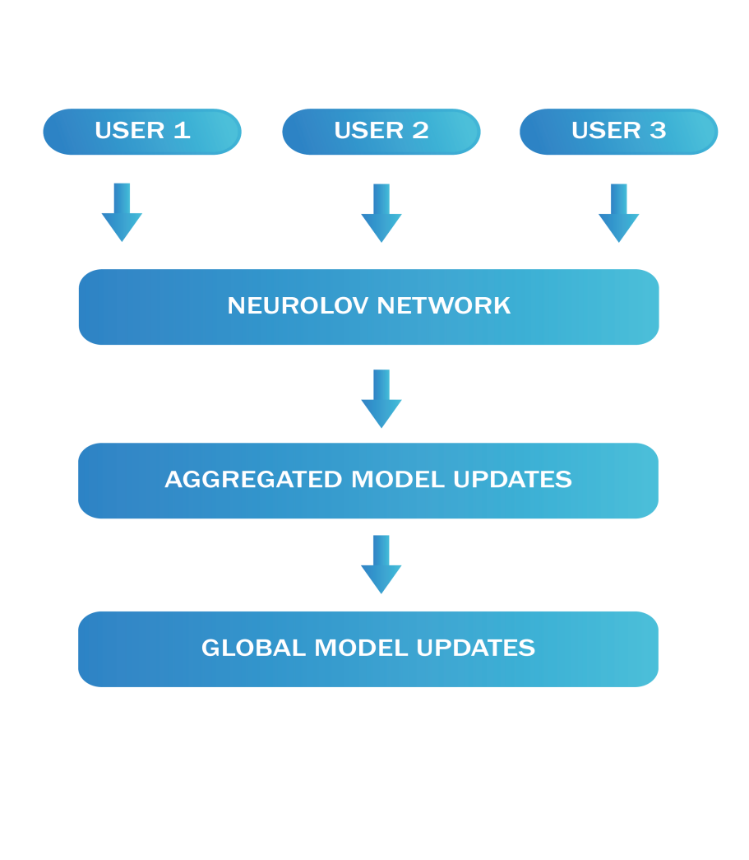  
Figure 8: Federated Learning Implementation

9.Performance and Scalability

we explore the critical aspects of performance and scalability in our system. We begin by examining our distributed GPU performance model, which forms the foundation of our high-performance computing architecture. This model leverages the power of distributed GPUs to achieve unprecedented processing capabilities. We then discuss how our system scales as the network grows, ensuring that performance improvements are maintained during expansion. The section also delves into strategies employed to minimize response times and maximize resource utilization across the distributed network. Finally, we present our innovative proof of computation mechanism, which verifies the integrity and correctness of computations performed across the distributed system, ensuring reliability and trust in the results produced by our scalable architecture.  
  
9.1 Distributed GPU Performance Model

Our distributed GPU performance model accounts for:

* *Individual GPU capabilities (FLOPS, memory bandwidth)*
* *Network latency between GPUs*
* *Task parallelization efficiency*

The performance is modeled as:

*P = (N * G * E) / (1 + L/C)*

Where:

*P = Overall performance*

*N = Number of GPUs*

*G = Individual GPU performance*

*E = Parallelization efficiency*

*L = Network latency*

*C = Computation time*

This model helps in predicting performance gains and optimizing resource allocation.

9.2 Scaling with Network Growth

As the Neurolov network grows, we implement several scaling strategies:

***Sharding***: *Dividing the network into sub-networks for improved throughput.*

***Layer-2 Solutions*:** *Implementing Solana-compatible L2 solutions for increased TPS.*

***Dynamic Node Recruitment***: *Automatically on-boarding new GPU providers to meet demand*

9.3 Latency and Efficiency Considerations

To minimize latency and maximize efficiency, we will:

* *Implement intelligent task routing to geographically closer GPU nodes*
* *Use predictive algorithms to pre-warm GPUs for anticipated tasks*
* *Employ caching mechanisms for frequently used models and datasets*
* *Optimize data transfer protocols to reduce network overhead*

9.4 Proof of Computation

Neurolov implements a robust Proof of Computation (PoC) system to verify the integrity of GPU computations:

***Task Commitment****: GPU providers commit to a task by staking Neurolov tokens*

***Computation Execution:*** *The task is performed on the GPU*

***Result Submission:*** *The provider submits the result along with a cryptographic proof*

***Verification****: Multiple nodes verify the proof using a fraction of the original computation*

***Consensus****: If the majority agrees, the result is accepted and the provider is rewarded*

12. Tokenomics  
  
The $NLOV token is the lifeblood of the Neurolov ecosystem, designed to incentivize participation, govern the platform, and facilitate seamless transactions. Neurolov tokens (NLOV) play a central role in our ecosystem, serving multiple utility functions to enhance user experience and incentivize participation. $NLOV are more than just a medium of exchange; they represent access, participation, and value within our decentralized computing ecosystem. By leveraging the diverse utility functions of NLOV tokens, users can unlock a range of benefits and opportunities while contributing to the growth and success of the Neurolov platform.

12.1 Token Utility

1. Access to Computing Resources: Users spend $NLOV to utilize GPU power and AI capabilities.
2. Staking and Governance: Token holders can stake $NLOV to participate in platform governance and earn rewards.
3. Incentives for Resource Providers: GPU providers earn $NLOV for contributing their resources to the network.
4. Payment for AI Models and Services: Used for transactions in the AI model marketplace and other platform services.

12.2 Token Allocation

Token allocation is a critical aspect of the overall tokenomics strategy, ensuring a balanced distribution of tokens to foster a healthy ecosystem and incentivize participation from various stakeholders. Neurolov’s token allocation strategy is meticulously designed to support platform growth, reward contributors, and maintain long-term sustainability.

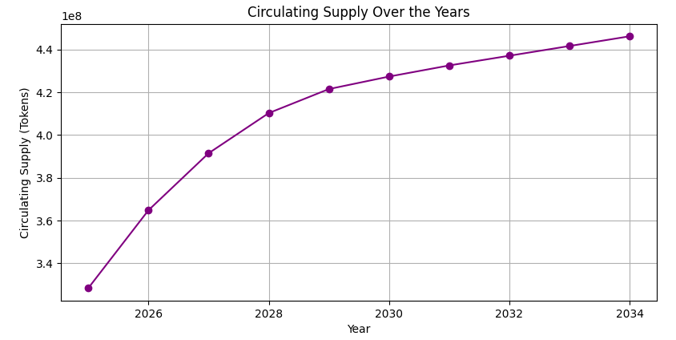  
Figure 9: NLOV Circulating Supply Over The Years

* Total Supply: 500 million $NLOV tokens
* Public Sale: 56% (280 million tokens)
* Ecosystem Development: 15% (75 million tokens)
* Team and Advisors: 8% (40 million tokens)
* Community Incentives: 10% (50 million tokens)
* Reserves: 10% (50 million tokens)

Neurolov's token allocation plan outlines the distribution of tokens across different categories, including team members, investors, ecosystem development, community incentives, and reserves. This approach ensures that tokens are strategically allocated to support both short-term and long-term goals, promoting a vibrant and engaged community.

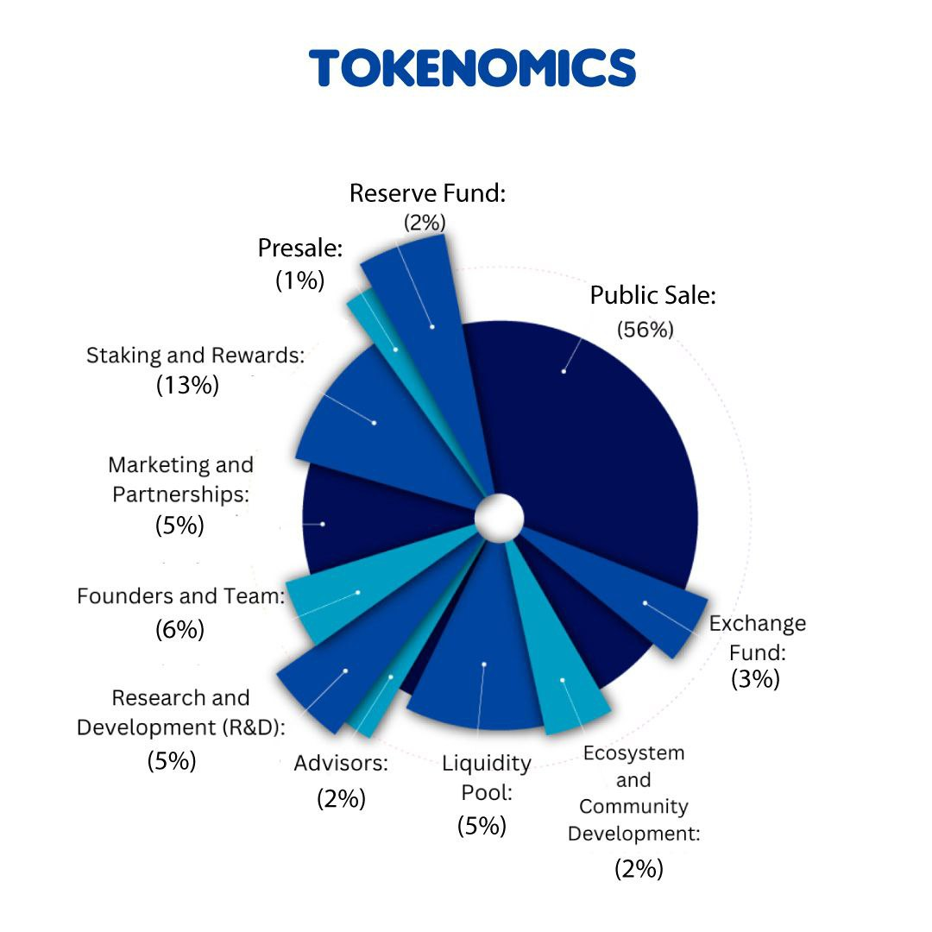

Figure 10: Token Allocation

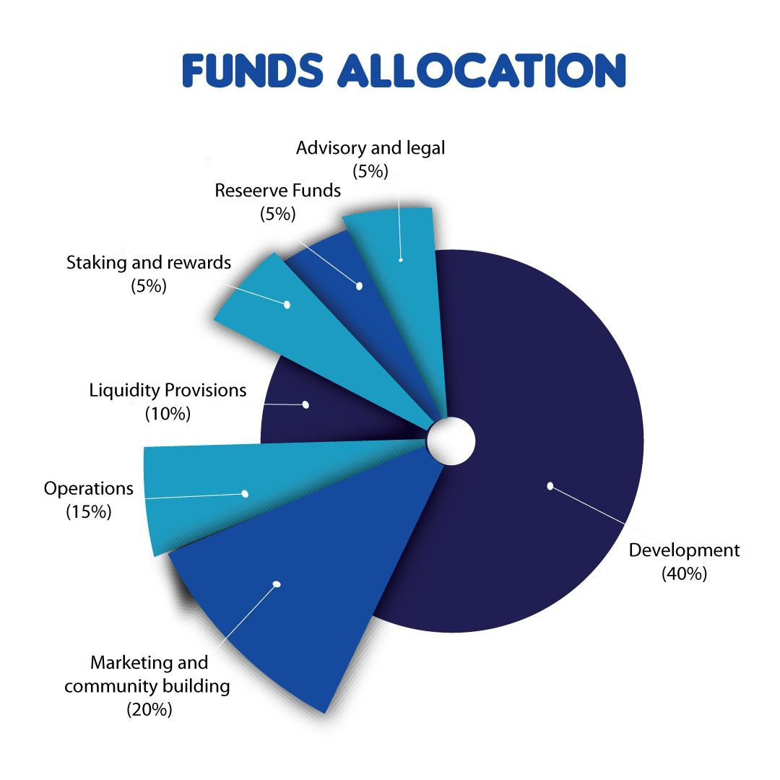  
Figure 11: Fund Allocation

12.3 Token Emission Schedule

The $Nlov token emission schedule is designed to ensure sustainable growth and long-term value appreciation while supporting the project's ecosystem development. The emission schedule outlines the gradual release of tokens over time, balancing initial liquidity needs with long-term sustainability goals.

* Initial Release: 20% of total supply at mainnet launch
* Gradual Release: Remaining tokens released over 5 years
* Emission Rate: Decreasing emission rate to ensure long-term sustainability

**Dynamic Rate Adjustment**: The emission rate of $Nlov tokens may be subject to dynamic adjustments based on project milestones, market conditions, and community consensus. This flexibility allows for responsive supply management, ensuring alignment with the project's strategic goals and market demand.

**Vesting and Release Mechanism:** Tokens allocated to team members, advisors, developers, and other stakeholders will follow a vesting schedule to incentivize long-term commitment and responsible token utilization. This mechanism prevents sudden market oversupply and supports sustained project development.

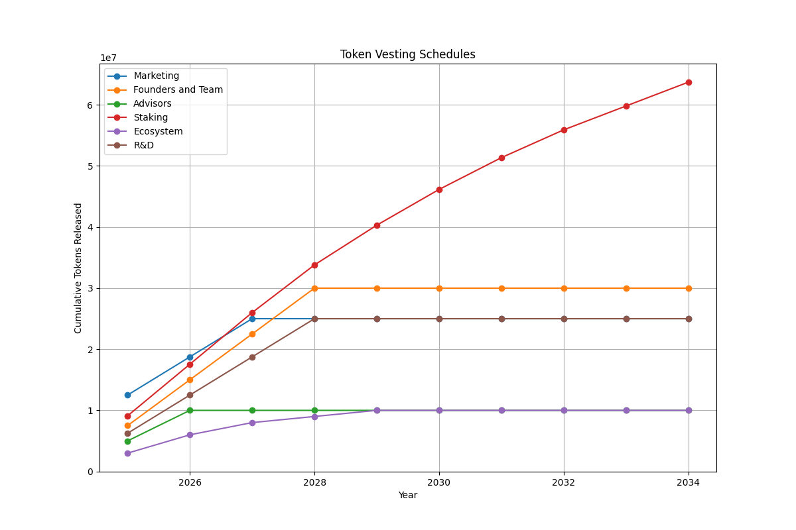  
Figure 12: Token Vesting Schedule

12.4 Staking and Rewards

Staking and rewards form a vital component of Neurolov's tokenomics, providing a mechanism for token holders to participate actively in the platform's ecosystem while earning rewards. This approach incentivizes long-term commitment, enhances network security, and ensures the efficient functioning of the platform.

**Staking Mechanism**

Neurolov employs a sophisticated staking mechanism designed to encourage participation and reward users for their commitment to the network. Key elements of the staking mechanism include:

1. **Staking Pools**: Users can stake their tokens in designated staking pools. These pools are tailored to different user profiles, offering varying levels of rewards based on the amount staked and the duration of the staking period.
2. **Smart Contracts:** The staking process is managed by smart contracts, ensuring transparency and security. These contracts automate the staking and reward distribution processes, minimizing the risk of errors and ensuring timely payouts.
3. **Lock-up Periods**: To encourage long-term commitment, staked tokens are subject to lock-up periods. The duration of these periods varies based on the staking pool and reward structure, incentivizing users to maintain their stake over extended periods.

This optimized tokenomics model is designed to create a self-sustaining ecosystem that rewards long-term participation, ensures platform liquidity, and aligns incentives for all stakeholders. By carefully balancing token distribution, emission, and utility, Neurolov aims to foster a thriving, decentralized marketplace for high-performance computing and AI development.

1. Roadmap

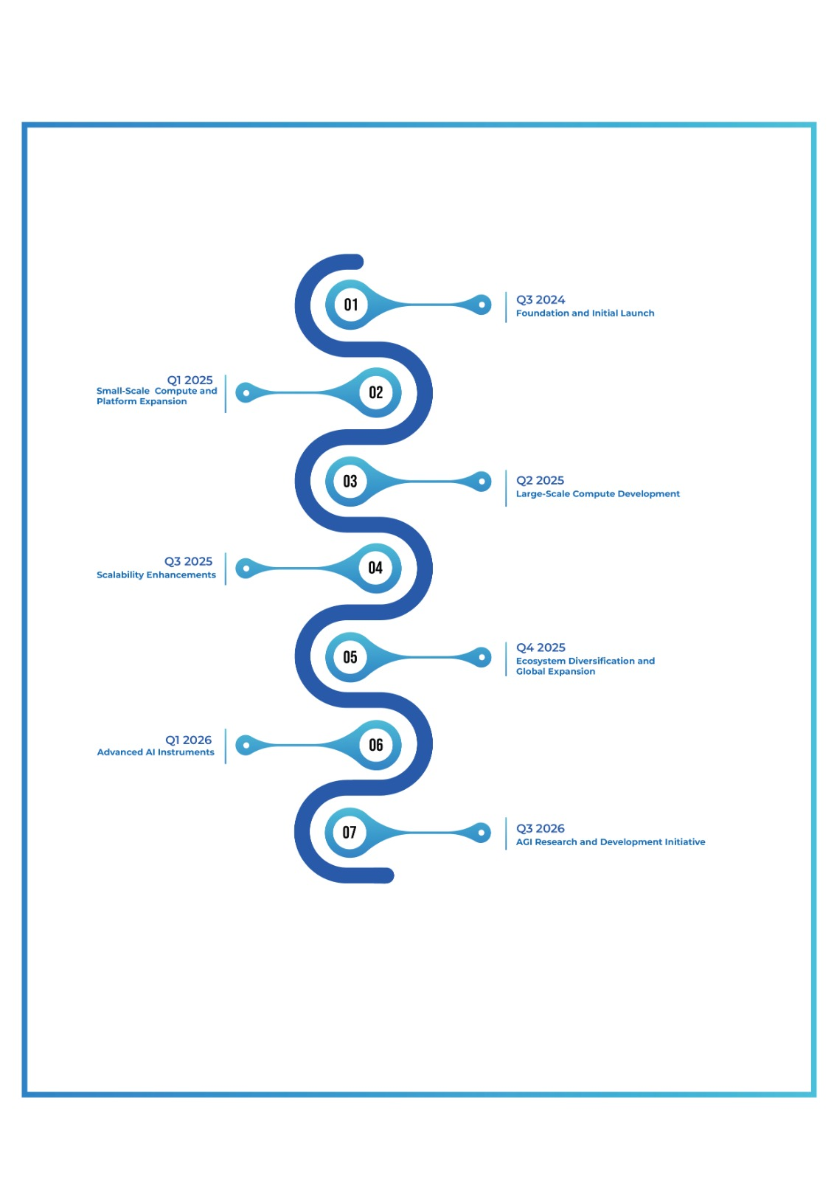  
Figure 13: Token Vesting Schedule

**Q3 2024: Foundation and Initial Launch**

* **Neurolov Grid Network**: Launch the beta version of the Neurolov grid network, enabling distributed computing
* **GPU Renting platform**: Release the initial version of the GPU compute renting platform with 1000+ GPUs available for public to rent.
* **Private and Public Sale:** Launch private and public token sales to raise funds for complete platform development and distribute tokens to early investors and the wider community.
* **Token Generation Event (TGE):** Conduct the Token Generation Event to mint and distribute the initial supply of $NLOV tokens
* **Initial Airdrop Campaign:** Execute the first airdrop campaign to distribute tokens to early adopters and generate initial community engagement.
* **Platform Development:** Complete the development of the core Neurolov platform, integrating blockchain, smart contracts, and initial AI modules.

**Q1 2025: GPU Renting Dapp and Platform Expansion**

* **LLM Integration:** Implement initial integration with existing LLMs, setting up the foundation for custom LLM development.
* **Small-Scale Training:** Develop and launch capabilities for users to train and build small-scale LLMs using Neurolov's GPU compute.
* **Staking and Rewards Program**: Launch the staking and rewards program, incentivizing both long-term holding and GPU compute contributors.
* **Liquidity Pools:** Establish initial liquidity pools on major decentralized exchanges (DEXs) to ensure token liquidity and facilitate trading.
* **User Authentication System:** Implement a secure and decentralized user authentication system leveraging blockchain technology.
* **Marketing and Community Building**: Initiate marketing campaigns highlighting Neurolov's LLM capabilities to attract AI researchers, developers, and general users.

**Q2 2025: Large-Scale Compute Development**

* **Large-Scale Capabilities:** Release of large scale GPU compute with almost 12000+ GPUs available for public to use.
* **Advanced AI Modules**: Release additional AI modules for data pre-processing, model training, and evaluation, tailored for LLM development.
* **Enhanced Front-end Interface**: Upgrade the front-end interface to improve user experience for development, training, and general platform use.
* **Governance Platform**: Launch the governance platform, allowing token holders to participate in decisions related to development priorities and overall platform direction.
* **Partnership Integration**: Fully integrate capabilities from the partnership with the model building & LLM firm, enhancing Neurolov's offerings.

**Q3 2025: GPU Scalability Enhancements**

* **Distributed Computing Framework:** Implement Kubernetes and or Mesos for improved task scheduling and resource management, optimizing training processes.
* **Data Storage Integration:** Integrate with additional databases like PostgreSQL and MongoDB, optimized for storing and retrieving large language models and training data.
* **Security Audits:** Conduct comprehensive security audits focusing on the GPU compute network, LLM training processes, and overall platform security.
* **Advanced Analytic Tools:** Introduce advanced analytic tools for users to better understand their staking rewards, liquidity pool performance, and LLM training metrics.

**Q4 2025: Ecosystem Diversification and Global Expansion**

* **Cross-Chain Compatibility:** Develop cross-chain compatibility to allow Neurolov Network and $NLOV tokens to interact with other blockchain networks.
* **Global AI Community Initiatives**: Launch global community initiatives targeting AI researchers, LLM developers, and users worldwide, including localized content and support.
* **Mobile App for Interaction:** Develop and release a mobile app allowing users to interact with and manage their GPU projects and access other platform features on the go.
* **Continuous LLM Innovation**: Based on user feedback and advancements in the field, continuously improve LLM training capabilities, model performance, and overall platform features.

**Q1 2026: Advanced AI Financial Instruments and Full Decentralization**

* **AI-Powered DeFi Integrations**: Integrate Neurolov's LLMs with major DeFi platforms to offer AI-enhanced financial instruments such as lending, borrowing, and yield farming.
* **Token Utility Expansion:** Implement new token utility features focused on accessing and utilizing advanced LLM capabilities, alongside token burn mechanisms to manage supply.
* **Full Decentralization of LLM Network**: Transition towards full decentralization of the LLM training and deployment network, empowering the community to govern and sustain Neurolov's ecosystem.
* **Ecosystem Milestones:** Celebrate major ecosystem milestones with special events, airdrops, and rewards, highlighting breakthrough achievements in LLM development on the Neurolov platform.

**Q3 2026: AGI Research and Development Initiative**

* **AGI Research Program:** Launch a dedicated research program focused on Artificial General Intelligence (AGI), leveraging Neurolov's advanced LLM capabilities and distributed compute network.
* **AGI Development Framework:** Begin development of a framework for AGI experimentation and testing within the Neurolov ecosystem.
* **Ethical AI Guidelines:** Establish comprehensive ethical guidelines and safety protocols for AGI research and development.
* **AGI Collaboration Network:** Create a collaborative network for AGI researchers and developers to share insights and resources within the Neurolov platform.
* **AGI Compute Allocation:** Dedicate a significant portion of the GPU compute network to AGI-focused tasks and experiments.
* **Community Engagement in AGI:** Initiate community discussions and governance proposals related to the direction and implications of AGI development on the platform.

14. Use Cases

Neurolov's platform enables a wide range of applications across various industries, leveraging its decentralized high-performance computing and AI capabilities:  
  
**14.1 Scientific Research**

* Complex simulations for physics, chemistry, and biology  
  Data analysis for genomics and pharmaceutical research  
  Climate modeling and weather prediction

**14.2 Financial Services**

* High-frequency trading algorithms  
  Risk assessment and fraud detection models  
  Cryptocurrency mining optimization

**14.3 AI and Machine Learning**

* Training and fine-tuning large language models (LLMs)  
  Computer vision applications for autonomous vehicles  
  Natural language processing for chatbots and virtual assistants

**14.4 Media and Entertainment**

* Rendering for 3D animation and visual effects  
  Real-time graphics processing for gaming  
  Content recommendation engines

**14.5 Healthcare**

* Medical image analysis and diagnosis  
  Drug discovery and development  
  Personalized treatment planning

**14.6 Industrial Applications**

* Predictive maintenance for manufacturing equipment  
  Supply chain optimization  
  Energy grid management and optimization

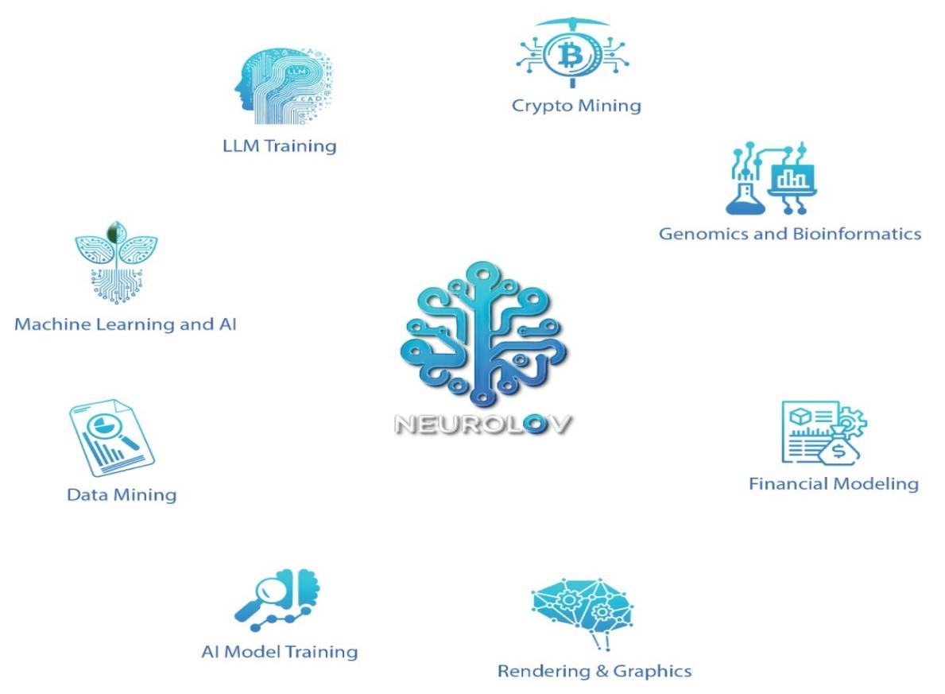  
Figure 14: Use cases

**15. Community and Governance**

Neurolov is committed to building a vibrant, engaged community and implementing a decentralized governance model that empowers token holders.  
 **Community Engagement:** We foster active engagement with our community through various channels, including social media, forums, and community platforms. We encourage open dialogue, feedback, and collaboration to ensure that community voices are heard and valued.

**Governance Model:** We are implementing a decentralized governance model where community members have a say in decision-making processes. Through voting mechanisms, stakeholders can propose and vote on changes, upgrades, and governance parameters of the platform.

**Native Token**: We facilitate voting mechanisms through smart contracts on the blockchain, enabling secure and transparent voting processes. Community members can submit proposals, vote on governance issues, and monitor voting outcomes in real-time.

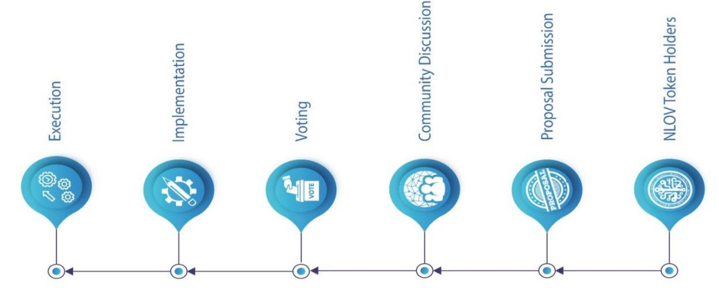  
Figure 15: Governance Flowchart

**Governance Proposals**: Community members can submit governance proposals for consideration by the wider community. Proposals may include changes to protocol parameters, funding allocations, or strategic initiatives aimed at improving the platform.

**Transparency and Accountability:** We are committed to transparency and accountability in governance processes. All governance proposals, voting outcomes, and decisions are recorded on the blockchain for public scrutiny and auditability.

**Incentivized Participation:** To encourage active participation in governance, We offer incentives such as voting rewards or governance staking rewards. These incentives   
motivate community members to engage in governance activities and contribute to the platform's development and success.

**Community Development Funds:** Allocates a portion of funds towards community development initiatives, including grants, bounties, and incubator programs. These funds support community-driven projects and initiatives that add value to the ecosystem.  
  
By empowering our community members and embracing decentralized governance principles, We aim to build a vibrant and inclusive ecosystem where stakeholders collaborate towards the common goal of advancing decentralized computing and AI technologies. Join us in shaping the future by unlocking the full potential of decentralized computing.

17. Conclusion

Neurolov stands at the forefront of a new era in decentralized computing and AI development. By addressing the critical challenges of resource underutilization, accessibility, and scalability, we are paving the way for unprecedented advancements in artificial intelligence and high-performance computing.

Our platform's unique combination of decentralized architecture, blockchain technology, and AI-driven optimization creates a powerful ecosystem that benefits all stakeholders – from individual GPU owners to large-scale AI researchers and developers.

As we progress along our roadmap, we remain committed to our vision of democratizing access to cutting-edge AI technologies and accelerating the path towards Artificial General Intelligence (AGI). With a robust tokenomics model, a growing community, and strategic partnerships, Neurolov is well-positioned to drive innovation and shape the future of computing.

We invite developers, researchers, and visionaries to join us on this exciting journey. Together, we can unlock the full potential of decentralized AI and computing, creating a more efficient, accessible, and intelligent world for all.

19. References  
1.https://www.globenewswire.com/en/news-release/2024/06/13/2898347/0/en/Global-High-Performance-Computing-Servers-Market-Size-Projected-to-Reach-26-Billion-By-2032.html

2. GPU Computing, John D. Owens, Mike Houston, IEEE | Vol. 96, No. 5, May 2008

3. LeCun, Y., Bengio, Y., & Hinton, G. (2015). Deep learning. Nature, 521(7553), 436-444.

4. Benet, J. (2014). IPFS - Content Addressed, Versioned, P2P File System.

5. Goyal, P., et al. (2017). Accurate, Large Minibatch SGD: Training ImageNet in 1 Hour.